# EXPERIMENT 4

**PRE-LAB:**

* 1. What is the method of specifying a primary key in a schema description?
  2. What do you mean by metadata?
  3. Explain UNION, MINUS and INTERSECT commands?
  4. Discuss about 12 Codd rules of Relational Databases.
  5. What is Relational Algebra?

pg. 12



# IN-LAB:

Draw an ER Diagram for a given Case Study 9 (**MILITARY DATABASE) CASE STUDY 9: MILITARY DATABASE**

To diminish the national defense expenditure and increment the war making capacity, the Indian military needs a computerized administration data framework staff the board. So, the Military chief's group have approached you to make a database. To assist you with this they gave you the accompanying information sources. The sources of info are as archives and records. Those records and Files can help you in getting knowledge into how their information can be put away, oversaw and recovered.

INDIAN Military has Different Divisions in it. It has:

* + 1. Army
    2. Navy
    3. Air Force

They likewise have a Special Science Division Which Designs and Manufactures various kinds of weapons, Warships, Heli-carriers and Fighter planes.

Armed force: An enormous sorted out group of equipped work force prepared for war particularly ashore. The officer’s ought to have explicit range of abilities to be in the military, they get the valor and respect dependent on their missions, battle aptitudes in serving the country and as indicated by their positions.

Naval force: The military arm of the country's sea armada, the Indian Navy, watches the seas so as to guard them. A common navy sending includes a few or more ships, submarines and maritime airplane squadrons taking part in exercises intended to guard the country.

Flying corps: The Air Force centers around flying, yet just a little division of work force really fly. Most aviators and airwomen deal with flight missions, taking care of base undertakings, securing bases, developing new airstrips, guarding rocket destinations, in any event, doing salvages.

The Database should also be included with the Soldiers personal details in the different divisions of Army (which contains Name, ID, Rank, Region of Service), Navy (Which contains Name, ID, Rank, Unit) and Flying Corps (Which contains Name, ID, Rank, Fly zone). The Army and the aviation based armed forces in some cases structures joint task force to work some Covert missions and stealth battle missions as does the Navy and Marines. The Military boss needs the details of the battle missions to be gotten to effectively in the database, the database contains the details for example: Mission name, Location, troops, CO (Commanding Officer), weapons. The battle missions additionally contain the officers served in it and the weapons utilized in it.

The group likewise needs to get to the worker information who works in the science division. The unique Science Division Makes the Weapons which are utilized in various Parts of the military, it makes strategic weapons, Warships which are utilized in naval force, Heli- transporters, the group Wants to store details of the weapons, for example: Name, Specifications, Category, Year of Design and ought to do likewise with Warships, Heli- carriers, Fighter planes.

The military keeps up Warehouses and weapon depots to store the weapons and the Equipment of the Military Personnel in better places, it gets hard to store this information in the structure documents, so the Military wants to Computerize this. He needs to store the details like Name of the stockroom ID, area of it, Category, Items stored, holding capacity.

pg. 13



The team also wants to modernize the Payroll details (Which contains the details like Name, Division, Designation, Age, Salary) of the officers and their Career record (Which contains the details like ID, Rank, Unit, Division, Age, Missions, Medals) in the data base. The Military also has the pantry division, the data base should contain the details such as S.no, location, Year of Establishment, Serving capacity. He also wants to computerize the details of pantry personnel like Name, ID, Designation, Joining year, Location of service. Another important Military division which is very essential is the Medical division it is the place where the wounded and the soldiers with extreme medical condition are healed, this data base should also include the details of Medical installations such as S.no, location, Year of Establishment, personnel count and also the information of Medical personnel which should include Name, ID, Joining year, specialization, Location.

The information provided by the Military team may not be complete and unambiguous. Please make necessary assumptions and create a first draft of the design of a data recording, maintaining and retrieval model.

pg. 14



# POST-LAB:

* + - 1. Discuss how to convert an ER diagram into a Relational model.
      2. From the ER model given below, we can say that it is a 1:1 cardinality with total participation constraint from Passport. Firstly, convert the diagram into a Relational model and then explain.

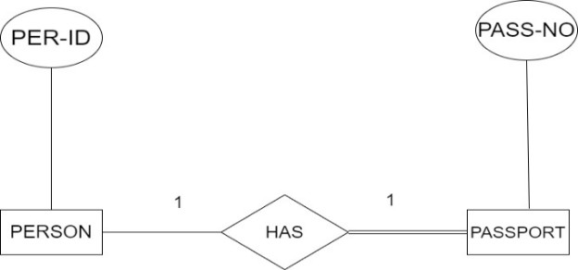

* + - 1. From the given ER model, we can say that it is an N:1 cardinality. Firstly, convert the diagram into a Relational model and then explain.

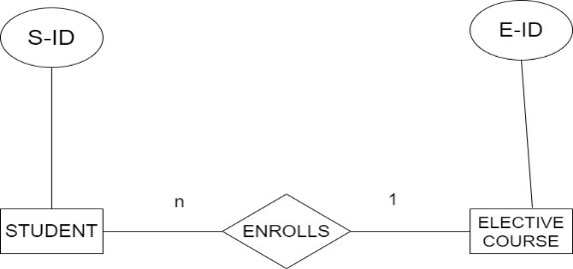

* + - 1. In regard with the below specified ER diagram, state to which domain does it related to: generalization or specialization and briefly state about overlapping specialization and disjoint specialization?

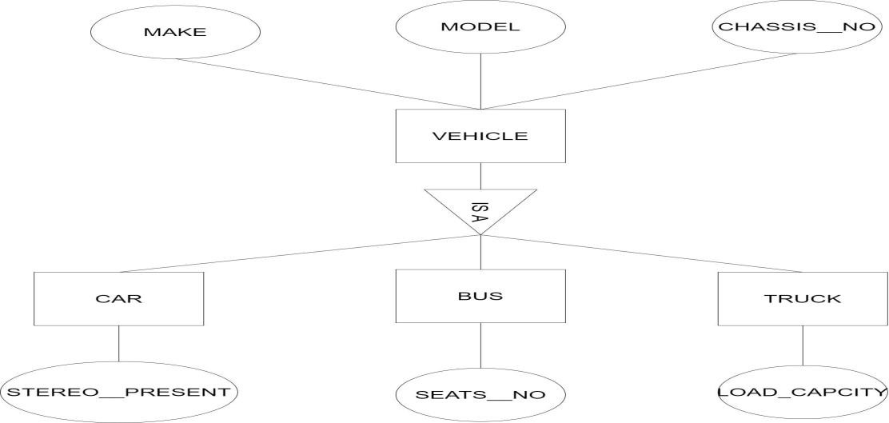

pg. 15



* + - 1. How does Tuple-oriented relational calculus differ from domain-oriented relational calculus?